# **Lecture 3**

**Session 3**

**Introducing Microsoft office 2019**

**Key points**

* **Introduction of Microsoft office**
* **What is MS office 365**
* **Exploring MS office**
* **What’s new in MS office 2019**
* **Understanding office 2019 edition**

**Introduction of Microsoft office 2019**

MS office is a client software and server software and services developed by Microsoft.

**Client-server software:**

A client is a computer or a program that, as part of its operation, relies on sending a request to another program or a computer hardware or software that accesses a service made available by a server For example, web browsers are clients that connect to web servers and retrieve web pages for display.

Microsoft office 2019 is a collection of office related applications.in which the each application has a unique purpose that they are providing to their users

Example

MS word

MS excel so on.

**Microsoft office 365**

Microsoft 365 is a subscription service that makes sure you always have the most up-to-date modern productivity tools from Microsoft. It is cloud based version of MS office and it offered as an online software as service (SaaS) product.

**Exploring MS office 2019**

There are several new feature are introduced by MS office for it each product but one of the feature is common to these several features is **RIBBON.**

In Microsoft Office applications, the Ribbon is the bar at the top of the window. It contains a variety of tools, organized by tabs that help you edit and format a document. A ribbon is designed to replace both the traditional menu bar and toolbar.

Each tab on a ribbon is composed of group, which are labeled set of closely related command.

**Quick Access Toolbar:** comprising frequently used command.

**Core Tabs:** those are always displayed.

**Contextual Tabs:** those are displayed only when a specific object is select e.g. table Tools and format tabs **dialog box launcher:** those buttons that are at bottom of some groups, after opening this buttons their containing features appeared that are related to that group.

**What’s new Office 2019?**

**Add Visual Impact:**

Bring visual interest to your documents, worksheets, and presentations by inserting Scalable Vector Graphics (SVG) that have filters applied to them.

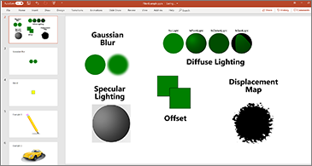

**Break the language Barrier:**

Translate words, phrases, and other text selections to another language with Microsoft Translator.

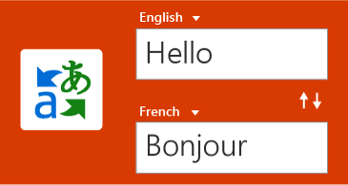

**LaTeX Equation Support:**

You asked for it! You can now create math equations using LaTeX syntax.

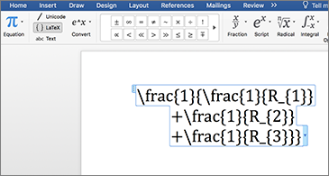

**Add Motion with Morph:**

Make smooth animations, transitions, and object movements across your slides with Morph.

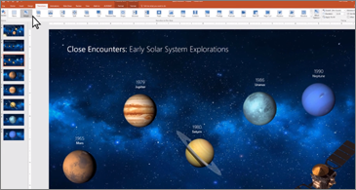

**Zoom for PowerPoint:**

Zoom takes you from one slide to another, in any order you like. Skip ahead or revisit slides without interrupting the flow of your presentation.

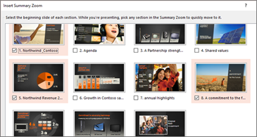

**Slideshows with Digital Pen:**

Use your Surface pen, or any other pen with a Bluetooth button, to advance your slides.

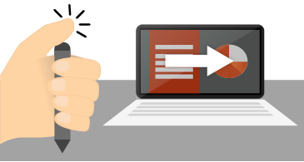

**Draw and write with ink in office 2019:**

On a touch-enable device you can draw with your finger, a digital pen, or mouse.

**Write Draw and Highlight Text**

Convert ink to shapes, write out complex math problems, highlight text, and more. Use a finger or a pen. A mouse works too!

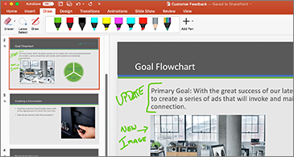

**Accessibility Checker:**

The Accessibility Checker is better than ever with updated support for international standards and handy recommendations to make your documents more accessible.

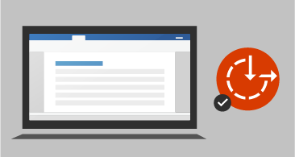

**Use Office Sounds:**

Turn on audio cues to guide you as you work. Audio cues are part of sound effects, which you can find in **Options** > **Ease of Access**.

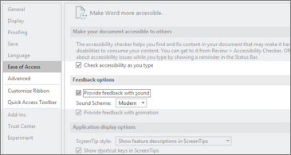

**Understanding Office 2019 Editions:**

Four major versions of Office 2019 for Windows and 2 for Mac OS were released for Office 2019:

* **Home & Student for PC/MAC:** Includes core applications only.
* **Home & Business for PC/MAC:** Includes core applications plus Outlook.
* **Professional:** Includes core applications plus Outlook, Publisher and Access.